Android-Based Lab Access Verification System



Group Members (Group 1)
Student Name | Student Number
Luxolo Luvalo | 202326649
Siphesihle Nzimase | 202232773
Phindile Khumalo | 202208089
Zusakhe Noguda | 223037156
Tinashe Crispen Garidzira | 201925693

Table of Contents
1. Introduction 2
2. Assignment Requirements Addressed 3
3. System Design 4
3.1 Main Components 4
4. Database Implementation 4
5. User Interface and Theme 4
6. Verification Logic and Input Validation 4
7. Additional Features 5
8. Screenshots 5
9. Testing and Demonstration Guide 5
10. Challenges Encountered 5
11. Conclusion 5
12. References 6

Introduction
The Lab Access Verification System was developed to address the problem of manual and inconsistent student access verification in Computer Science laboratories, where security personnel or laboratory assistants may rely on paper lists, memory, or informal confirmation to decide whether a student is allowed to enter. Manual verification is inefficient and prone to human error, especially in university environments where smart-campus research increasingly emphasises the need for digital systems that improve campus management, safety, service quality, and operational decision-making (Mustafa et al., 2025; Polin et al., 2024). In this context, the absence of a simple digital verification tool can result in delayed entry, incorrect access decisions, poor accountability, and limited evidence when access disputes occur (Polin et al., 2024; Wang et al., 2022). Therefore, the main problem addressed by this project is the need for a reliable Android-based system that can quickly verify whether a student is authorised to enter a laboratory using locally stored student records (Mustafa et al., 2025; Wang et al., 2022).
The proposed application provides a practical solution by allowing security personnel to enter a student number, press the VERIFY button, and immediately receive either ACCESS GRANTED or ACCESS DENIED based on the student’s existence and permission status in the database. This workflow supports the broader smart-campus objective of using mobile and digital technologies to improve institutional services and access-control processes (Mustafa et al., 2025; Polin et al., 2024). The application was implemented using Java for the application logic, XML for interface design, and Material Design principles to ensure that the system remains simple, usable, and professional for non-technical users (Polin et al., 2024; Wang et al., 2022). Usability is important because access-control technologies are more likely to be accepted when users perceive them as useful, easy to operate, and relevant to their daily tasks (Wang et al., 2022).
The system uses Room Database backed by SQLite to store approved students locally on the Android device, which makes the application suitable for environments where internet access may be unavailable, unstable, or unnecessary for basic verification. SQLite is widely recognised as a lightweight local database option for Android-based data storage, while Room improves database interaction by providing a structured persistence layer over SQLite (Abbas et al., 2025; Raes et al., 2025). The database stores key student information such as student number, student name, and access permission status, while the application also records verification attempts as access logs containing the student number, result, officer identifier, and timestamp. These features strengthen accountability, support later review of laboratory access activity, and demonstrate how Android programming, input validation, local database integration, and object-oriented design can be combined to solve a real university access-control problem (Mustafa et al., 2025; Taipalus, 2024).

Assignment Requirements Addressed
Table 1 shows how the implemented Lab Access Verification System directly addresses the main functional and assessment requirements of the assignment. The system provides a numeric student number input field using TextInputEditText, supported by Java validation to prevent empty or invalid submissions. The VERIFY button is implemented using a MaterialButton and triggers the verifyStudent() method in MainActivity, which checks the entered student number against the local Room database. The verification result is displayed clearly in a status card as either ACCESS GRANTED or ACCESS DENIED, with student details shown when the student is authorised. The database requirement is fulfilled through Room Database backed by SQLite, which stores approved students and access log records.
Table 1. Alignment Between Assignment Requirements, System Implementation, and Marking Criteria
Requirement | Implementation | Marking Benefit
Student Number Input | TextInputEditText accepts numeric values only and uses Java validation before verification. | Supports input validation marks.
VERIFY Button | MaterialButton labelled VERIFY calls verifyStudent() in MainActivity. | Meets core interaction requirement.
Access Result | Displays ACCESS GRANTED or ACCESS DENIED in a status card with student details. | Addresses verification logic and UI marks.
Local Database | Room Database creates students and access_logs tables in SQLite. | Addresses database implementation marks.
Sample Data | All assignment-provided student numbers are seeded on first app launch. | Allows demonstration immediately after install.
Documentation | README.md and this Word report are included in the project package. | Addresses documentation marks.
Documentation | README.md and this Word report are included in the project package. | Addresses documentation marks.
The assignment sample student numbers are also seeded automatically during the first app launch, making the application ready for testing and demonstration immediately after installation. Finally, the inclusion of both the README.md file and the Word report strengthen the documentation component of the submission. The repeated documentation row should be removed from the table to avoid duplication and improve presentation quality.

System Design
The application follows a simple layered design that separates the user interface, business logic, and database access. MainActivity controls the screen state, validates input, and updates the result view. Room entities model the data tables. DAO interfaces provide database operations, while AppDatabase manages the SQLite-backed Room database instance and sample data seeding.

3.1 Main Components
- MainActivity.java: Handles login, student verification, status display, input validation, dark mode and access-log rendering.
- Student.java: Room entity representing approved students with studentNumber, studentName and accessAllowed fields.
- AccessLog.java: Room entity representing verification attempts.
- StudentDao.java: Provides the query for finding a student-by-student number and inserting sample students.
- AccessLogDao.java: Stores logs, retrieves recent logs and clears logs.
- AppDatabase.java: Room database singleton that creates and manages the SQLite database.

Database Implementation
Room Database is used because it provides a safer object-oriented layer over SQLite while persisting information in a local SQLite database file. The database is named lab_access_verification.db and contains two tables: students and access_logs.
Table 2. Structure and Purpose of the students Database Table
Field | Data Type | Purpose
studentNumber | String | Primary key used for verification.
studentName | String | Optional display name shown for granted access.
accessAllowed | Boolean | Determines whether the student may enter the lab.

Table 3. Structure and Purpose of the access_logs Database Table
Field | Data Type | Purpose
id | Long | Auto-generated primary key.
studentNumber | String | Number entered by the security officer.
studentName | String | Matched name or Unknown Student.
result | String | ACCESS GRANTED or ACCESS DENIED.
officerId | String | Logged-in officer who performed verification.
verifiedAt | String | Date and time of verification.

User Interface and Theme
The interface was redesigned to match the lab access scenario. It includes a security login card, a student verification card, a strong status result section, and a recent access log section. The design uses the requested Color Hunt palette: #E8EDF2, #2C3947, #547A95 and #C2A56D (Hunt, 2026). These colours provide a clean institutional style with strong contrast for security feedback.

Verification Logic and Input Validation
When the VERIFY button is pressed, the application first checks whether the student number field is empty. It then verifies that the value contains digits only. If validation passes, the application searches the students table for the entered student number. If a matching student exists and accessAllowed is true, the system displays ACCESS GRANTED. If no matching record exists, the system displays ACCESS DENIED. Each attempt is saved into the access_logs table with the officer ID and timestamp.

Additional Features
- Security personnel login using Officer ID and PIN.
- Access logs with date and time recording.
- Search history/recent access history displayed inside the app.
- Dark mode toggle for improved usability.
- Material Design Components for TextInputLayout, MaterialButton, MaterialCardView and SwitchMaterial.
- Professional status cards that change colour for granted and denied results.

Screenshots
Table 4. Sample screenshots of the system.
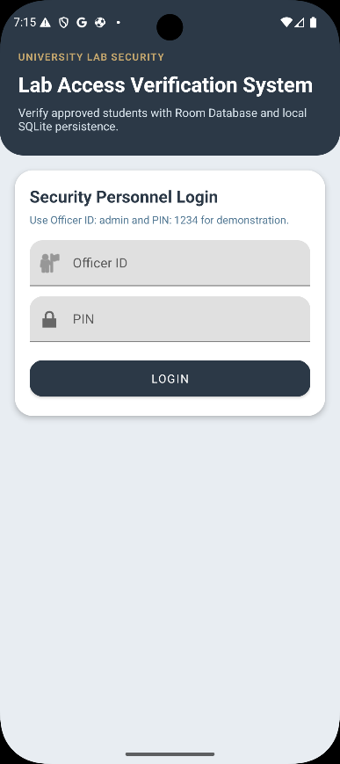 | 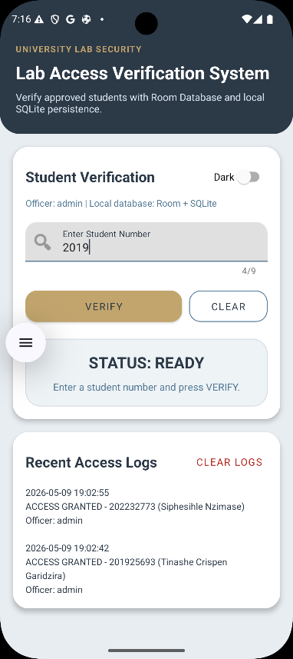 | 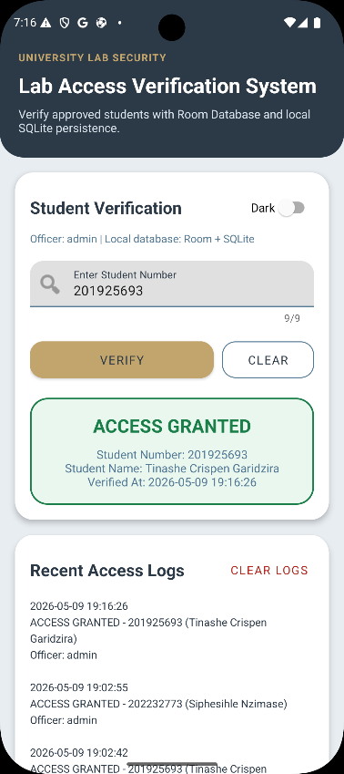 | 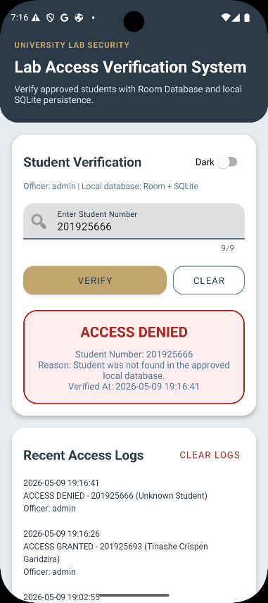

Testing and Demonstration Guide
- Open the project in Android Studio and run it on an emulator or Android device.
- Login using Officer ID admin and PIN 1234.
- Enter 202232773 and press VERIFY. The expected result is ACCESS GRANTED.
- Enter 123456789 and press VERIFY. The expected result is ACCESS DENIED.
- Press VERIFY with an empty field. The expected result is an input-required error.
- Check that each verification attempt appears in Recent Access Logs.
- Toggle dark mode to demonstrate the bonus theme feature.

Challenges Encountered
The original attached project was not designed for laboratory access verification; it was structured around a book-shop scenario. The major challenge was therefore refactoring the project into a clean, focused system that directly matches the assignment. Another challenge was ensuring that Room database operations run off the main UI thread so that the application remains responsive and does not crash during database queries.

Conclusion
The Android-Based Lab Access Verification System successfully addresses the problem of manual and inconsistent student verification in Computer Science laboratories by providing a simple, reliable, and locally supported digital access-control solution. The system allows security personnel to enter a student number, press the VERIFY button, and immediately receive either ACCESS GRANTED or ACCESS DENIED, which directly satisfies the main purpose of the assignment. It also meets the required technical implementation by using Java for application logic, XML for interface design, and Room Database backed by SQLite to store approved student records and verification logs locally on the Android device.
In addition to the core requirements, the application includes relevant bonus features such as security personnel login, input validation, recent access logs, timestamp recording, dark mode, and Material Design components, which improve usability, accountability, and demonstration quality. The final system shows how Android development, object-oriented programming, local database integration, and user-interface design can be combined to solve a practical university access-control problem. Although the original project required major refactoring from a book-shop application into a laboratory verification system, the completed application is now focused, functional, and suitable for classroom demonstration, with room for future improvements such as QR-code scanning, biometric login, cloud synchronisation, and an administrative dashboard.

References
Abbas, M., Amjad, M. U., Zubair, S., Amin, A., Arif, S., & Khan, M. A. I. (2025). Unraveling database choices in Android Studio: A comparative analysis of SQLite and Room Persistence Library. Contemporary Journal of Social Science Review, 3(1), 602–611.
Hunt, C. (2026). Hunt Color. Hunt, Color. https://colorhunt.co/palette/e8edf22c3947547a95c2a56d
Mustafa, R., Khan, T. A., & Sarkar, N. I. (2025). A Secure and Sustainable Transition from Legacy Smart Cards to Mobile Credentials in University Access Control Systems. Information, 16(12), 1073. https://doi.org/10.3390/info16121073
Polin, K., Yigitcanlar, T., Washington, T., & Limb, M. (2024). Unpacking Smart Campus Assessment: Developing a Framework via Narrative Literature Review. Sustainability, 16(6), 2494. https://doi.org/10.3390/su16062494
Raes, R., Ruas, O., Luxey-Bitri, A., & Rouvoy, R. (2025). INTACT: Compact Storage of Data Streams in Mobile Devices to Unlock User Privacy at the Edge. Journal of Internet Services and Applications, 16(1), 372–387. https://doi.org/10.5753/jisa.2025.5242
Taipalus, T. (2024). Database management system performance comparisons: A systematic literature review. Journal of Systems and Software, 208, 111872. https://doi.org/10.1016/j.jss.2023.111872
Wang, Q., Hou, L., Hong, J.-C., Yang, X., & Zhang, M. (2022). Impact of Face-Recognition-Based Access Control System on College Students’ Sense of School Identity and Belonging During COVID-19 Pandemic. Frontiers in Psychology, 13. https://doi.org/10.3389/fpsyg.2022.808189

